Name: Addison Kelly
Student ID: 1237585871
Date: 04/27/26

Instructions: You should have at least three pages (3 html files and 1 css file) of your site completed by the time you submit this. Use the following to have a written discussion about the current progress of your website. After you answer the questions below, insert a screenshot of each of the pages you have completed so far (remember, you should have at least 4 and the CSS file). Do NOT screenshot the html code because we can’t run the code. Save the file to yourasurite – Project Assignment – Project Update 2.docx file and yourasurite – Project Assignment – Project Update 2.pdf file. Submit both files to Canvas.

- How do you feel your website is coming along? (10 points)

I feel that with spending more time on my website using methods from class assignments and with the assistance from Copilot and ChatGPT it is coming along much better than before. I’m starting to achieve the feel that I want, though I’ve altered some aspects including the color scheme.

- Since your last update, have you encountered any issues? (4 points) If so, describe what they were and how you resolved them. (3 points) Are there any issues still unresolved? (3 points)

I have experienced some issues. One example is when the paragraph in index.html was not centered on the page. Upon researching why, I determined I was coding the text alignment centered but not centering the text on the page itself.

- Your final project is almost done, outline what you have left and how you plan on completing it: (10 points)

I have to add more content to the main home page, including a tips section on the left. I also need to create a camera page and add little details to each.

- List your project website's GitHub URL. (10 points)

akellyhappyfree.github.io (For some reason when I visit this, even though I uploaded my updated files, it’s showing me a previous version of my website and I don’t know why.)

- Videos can be a powerful tool on websites, helping to engage visitors by providing visual demonstrations, tutorials, product showcases, or entertainment. They can enhance the user experience by offering dynamic content that complements text and images. Videos are especially useful for conveying complex information in an easy-to-understand format.

Where would you like to use videos on your website? (2 points) How many videos will you include, and what videos will you create? (2 points) What do you hope to achieve with them (6 points)

I only now came up with the idea to use a video on the main page, something that generates a cool and exciting feeling interesting the viewer in to photography. I don’t know yet exactly what the content will be.

- See your website’s readiness scores. Open your website in Chrome, right click your mouse to find Inspect. Click Inspect to find Lighthouse. Click Lighthouse to see the website’s readiness scores. Screenshot those scores and insert the Lighthouse report below: (10 points). The report should include performance, accessibility, Best Practices, and SEO scores.
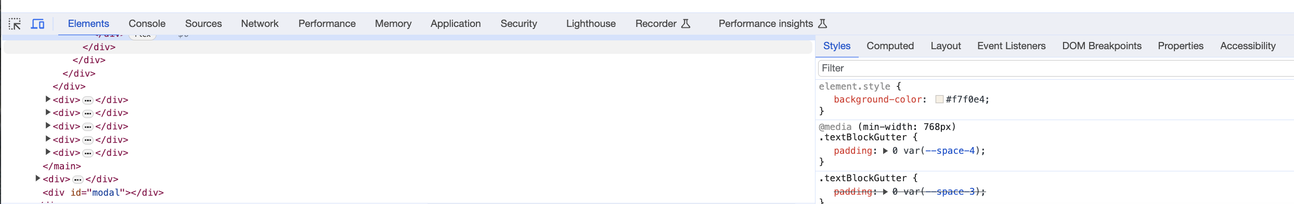

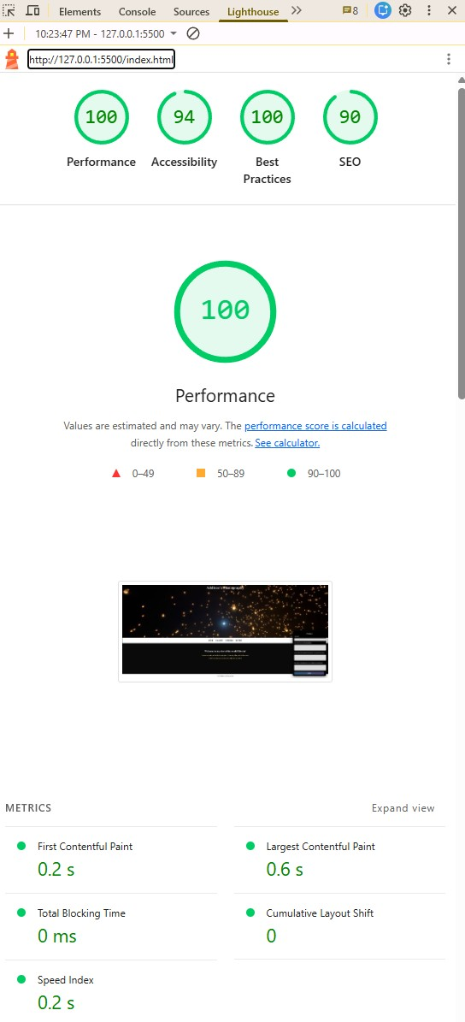
Web page browser view screenshot of Page #1 (10 points)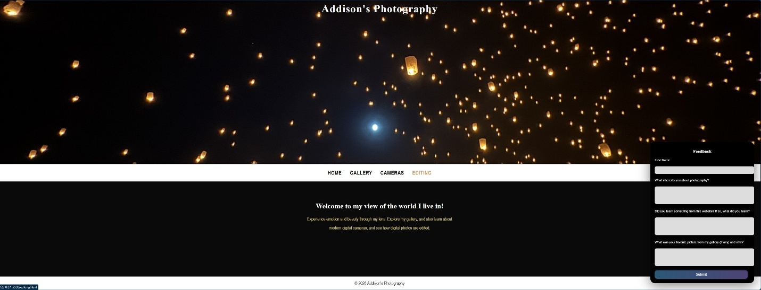

Web page browser view screenshot of Page #2 (10 points)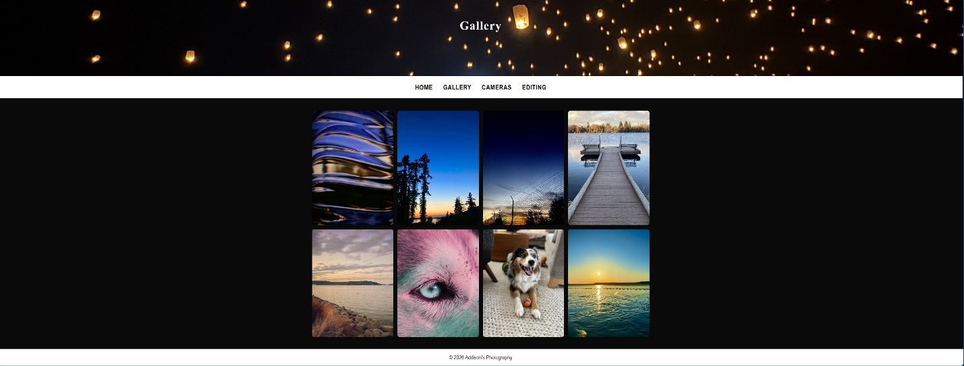

Web page browser view screenshot of Page #3 (10 points)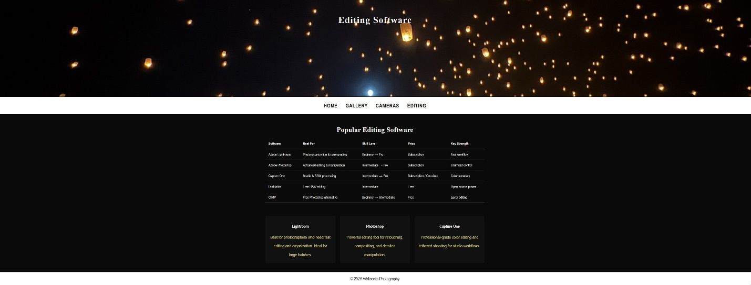

screenshot of the CSS code (10 points)

